**BUK ELECTRONIC TICKET BOOKING SYSTEM**

**  
BY**

**NASIRU USMAN HARUNA**

**CST/17/COM/01023**

**BEING A PROJECT SUBMITTED TO THE DEPARTMENT OF COMPUTER SCIENCE, FACULTY OF COMPUTING, BAYERO UNIVERSITY KANO IN PARTIAL FULFILMENT OF THE REQUIREMENT FOR THE AWARD OF BACHELOR OF SCIENCE DEGREE (B.SC HONOURS) IN COMPUTER SCIENCE.**

**SUPERVISED BY: MALAM RILWAN ADAMU DISO**

# MAY 2023

# DECLARATION

I, Nasiru Usman Haruna declare that this project work is the product of my own endeavor and that all sources have been adequately and duly acknowledged, and that all the inadequacies in this project work are the product of my own shortcomings. And that this project paper has not been submitted to this faculty or elsewhere.

**…………………………………………… ………………………**

# Nasiru Usman Haruna Date

# CERTIFICATION

# This is to certify that the research for this project and the subsequent write-ups by Nasiru Usman Haruna with registration number CST/17/COM/01023 were carried out under my supervision.

**………………………………… …….** **………………………**

Malam Rilwan Adamu Diso Date

(Supervisor)

# DEDICATION

I dedicate this work to Almighty Allah and to my Ever Loving Parents Malam Usman Haruna Barde, Malama Rabi’atu Adamu, and Malama Lauratu Abubakar. My adorable siblings and my lovely Aunty Hajiya Amina Haruna Barde and a friend Jamilu Adamu Abdullahi for the support, prayers, confident and encouragement they have rendered to me during my stay in this institution.

# APPROVAL PAGE

This project has been read and approved as meeting the requirements for a Bachelor of Science project in the Department of Computer Science, Faculty of Computing, Bayero University Kano.

................................... .................................

NAME DATE

Supervisor

..................................... ....................................

NAME DATE

Head of Department

.................................... ....................................

External Examiner DATE

# ACKNOWLEDGEMENT

Words alone cannot express the joy in my heart for the unmerited favor I have received during my stay in this institute, all praise, honor, and thanksgiving be ascribed to Almighty Allah who has made this project a reality. Blessed be His Most Holy Name.

I owe a debt of gratitude to my family member for their tireless support both spiritually, financially, morally, and otherwise during my program

My profound appreciation goes to my project supervisor and my level coordinator, Malam Haruna Usman Yakubu for his endurance, commitment, guidance, support, and encouragement which enabled me to complete this work to a standard of this nature. God bless you in all your endeavors.

I also acknowledge the effort of my Head of Department, Dr. Habiba Adamu Kakudi, and my mentor Prince Achoja for his absolute confidence in me, thank you, sir. Not forgetting all lecturers and staff of the faculty of computer science and information technology, your efforts will surely not go in vain, God Bless you all.

Finally, my sincere appreciation goes to the entire course mates and friends; Abdulkadir Santali Usman, Ibrahim Habib Muhammad, Bashir Ibrahim Muhammad, Mujibu Murtala, and the entire class of 2021 FCSIT.

# *ABSTRACT*

*The electronic ticketing booking system is aimed to automate the manual way of ticket purchasing for Bayero University Kano students. The Deanery of student affairs can carry out the online ticketing purchase and have full interaction with the students of the university more efficiently and reliably. The student will be able to use the new system to reserve a seat online, pay for it, and check the availability of a seat, while the deanery of student affairs and the counter attendant will be able to view the reserved ticket, answer inquiries, and maintain the records of students. Utilizing the proper modeling tools, the system's study and design were completed and incorporated into a single system. The students must register before having access to the platform. The student is enabled to top-up his wallet to allow him an online payment or payment with a credit card after he checks the availability and chooses his terminal and time of travel. The ticket cannot be lost or forgotten because of the ability of the system to save the booking history. For inquiries, students were provided with a contact page to allow them to send a suggestion, complaints, or reports.* *Targeting students that make use of school buses, specifically Students Affairs buses (moving from the new campus to the old campus). These buses were controlled and managed by the student affairs of the university*. *Emergence of new technologies would enable improving functionalities such as; live chat features, to enable effective communication, cancel of booked ticket instantly. Live view of the movement of the buses between the two campuses should be enabled to ensure reliability of the system.*

# TABLE OF CONTENTS

TITLE PAGE i

DECLARATION ii

CERTIFICATION iii

DEDICATION iv

APPROVAL PAGE v

ACKNOWLEDGEMENT vi

ABSTRACT vii

TABLE OF CONTENTS viii

**CHAPTER ONE**

**INTRODUCTION**

1.1Project Background: 1

1.2 Problem Statement: 1

1.3 Proposed Solution: 2

1.4 Aims and Objectives: 2

1.5 Project Justification: 2

1.6 The Scope of the Project: 3

1.7Project Limitations: 3

**CHAPTER TWO**

**LITERATURE REVIEW**

2.1 Introduction: 4

2.2 Existing System: 4

2.2.1 Development of an Online Bus Ticket Reservation System for a Transportation Service in Nigeria. 4

2.2.2An In-Depth Study of Mobile Ticketing Services in Urban Passenger Transport State-of-the-Art and Future Perspectives 5

2.2.3 Developing a Bus Ticket Reservation Web Application 6

2.2.4 Automated Bus Ticket Reservation System for Ethiopian Bus Transport System. 6

2.2.5 Online Bus Ticket Reservation System 6

2.2.6 Application of Online Tickets as a Method in Purchasing Bus Tickets. 7

**CHAPTER THREE**

**METHODOLOGY**

3.1 Introduction 9

3.1.1 System Development Methodology 9

3.1.2 Justification for the Methodology 10

3.1.3 Methods of Data Collection 10

3.2 Data Analysis Tools and Techniques 11

3.3 Feasibility Study 11

3.3.1 Social operational feasibility 11

3.3.2 Legal feasibility 11

3.5.3 Economic/Financial Feasibility 12

3.3.3 Technical feasibility 12

3.4 Description of the existing system 12

*3.4.1 Overview of the existing system* 13

*3.4.2 Shortcomings of the existing system* 13

3.5 Description of the proposed system 13

3.6 System Design Approach 13

*3.6.1 Advantage of the Proposed System.* 14

3.7 Requirement Definition 15

*3.7.1Functional requirements:* 15

*3.7.2Non- Functional requirement:* 15

3.8 Requirement Analysis: 16

3.9 Requirement Design: 18

3.9.1 Activity diagram 19

3.9.2 Class diagram 22

22

**CHAPTER FOUR**

**SYSTEM IMPLEMENTATION AND TESTING**

4.1 Introduction: 23

4.2 Implementation: 23

4.2.1. *Methods for Implementation* 23

4.2.2. *The Interface* 24

4.3Testing 39

4.3.1Unit Testing 39

4.3.2 System Testing: 44

**CHAPTER FIVE**

**SUMMARY AND CONCLUSION**

5.1 Introduction 45

5.2 Summary 45

5.3 Conclusion 46

5.4 Recommendation 46

REFERENCES 47

# CHAPTER ONE:

# INTRODUCTION

# 1.1Project Background:

The purpose of this chapter is to define the project history, problem statement, objectives, scopes, project relevance, and expected system output. The system is known as the Bus Ticket Reservation System. This is a project on the online ticketing system of a Deanery of student affairs (BUK) bus operator, which frequently has issues with its ticketing and scheduling processes. This project proposes to computerize its semi-computerized ticketing system to improve students’ service; as a result, the department (Deanery of students’ affairs) can offer a more convenient mode of transportation to the students or passengers. Electronic tickets, often known as e-tickets, provide proof to utilize a mode of transportation. Bus Ticket Reservation System allows bus operators' customers to purchase online tickets, which is the easiest and quickest way to take the bus. An online method is a novel approach because it is just getting roots in bus companies globally and even in Nigeria. The system will allow students to book a ticket, make payment for the ticket online, check the availability of the buses at the pickup point, and also gain information about the bus operators.

# 1.2 Problem Statement:

Because the present way of ticket purchase is carried out manually, which is a very active and time-consuming approach, bus ticket purchasing has been one of the key issues among students.

Students from various departments, the majority of whom are located far from the bus pickup point, are unlikely to be aware of the availability of buses at the boarding point, causing them to prolong their arrival/departure from school. Students are unable to purchase bus tickets online at this time but must visit the counter to do so. Students may have to wait in a long line to purchase a bus ticket and obtain information. Furthermore, students are not permitted to purchase bus tickets over the phone, students are greatly inconvenienced as a result of this.

Another issue with the manual procedure is the expense of the printing of papers (tickets) every day.

# 1.3 Proposed Solution:

The solution to this problem is to set up an electronic ticket booking system.

Customers can purchase bus tickets online 24 hours a day, seven days a week, and the tickets cannot be lost, stolen, or left behind. Students can book tickets after checking the availability of the buses at the pickup point, make payments, cancel reservations, and request information online.

# 1.4 Aims and Objectives:

The aim of this project is to bring a lasting solution to the students of Bayero University Kano and the deanery of student affairs by providing an online bus ticket reservation system to the students where both parties will benefit from the solution.

The main objectives of the online system are as follows:

* To provide web-based bus ticket reservation services, Customers can purchase bus tickets online, minimizing the need to stand in line at the counter.
* Allowing customers to check the availability of bus tickets online.
* To make it easier to pay for bus tickets online, the customer must pay for the bus ticket using his wallet money services.
* Reducing the number of employees at the point of sale, after the debut of the online bus ticket reservation system, the number of employees at the counter may be reduced.

# 1.5 Project Justification:

As previously said, the online system is still in its early stages, it is critical to the students, and everyone else since they may check the availability of bus tickets, purchase bus tickets, cancel bus tickets, and pay for bus tickets online. E-tickets differ from traditional paper tickets in that they are safer, faster, more reliable, and less expensive. Furthermore, this principle can be applied by other bus companies to ensure that their clients are satisfied. The bus company's earnings will improve since the online system will attract more consumers and there will be no need to recruit many staff members at the counter to sell bus tickets because tickets can be sold efficiently online.

# 1.6 The Scope of the Project:

The application is web-based. By logging in through the customer portal, users will receive access to the available buses and available seats.

The employees will gain access to the system by logging in through the staff portal, where they will be able to compare bus performance and monitor other associated business performance issues.

# 1.7Project Limitations:

* User acceptance: Some staff employees may be reluctant to make the counter system available online for fear of losing their jobs.
* Level of computer literacy: the intended clients may lack the necessary ICT abilities to benefit from the suggested system. By providing to train their consumers, the company may incur certain fees.
* Inadequate system testing: Inadequate unit and system testing may result in usability concerns such as delays in some modules.

# CHAPTER TWO

# LITERATURE REVIEW

# 2.1 Introduction:

This chapter aims to give a comprehensive overview of the existing literature on the Online Bus ticket reservation system. This system is a novel idea that leverages digital technology to make booking bus tickets more convenient and efficient.

# 2.2 Existing System:

# 2.2.1 Development of an Online Bus Ticket Reservation System for a Transportation Service in Nigeria.

Visitors may check bus ticket availability, purchase bus tickets, and make bus ticket payments online using the Online Bus Ticket Reservation System, a web-based program (Oloyede, M.O, Alaya, S.M and Adewole, K.S, 2014).

After receiving access from the administrator, this system is set up for all home/office users. As stated by (Oloyede et al, 2014). The online bus reservation system offers bus transportation, the ability to reserve seats, the ability to cancel reservations, and the ability to handle various sorts of inquiries that call for an immediate reservation (Oloyede and Callista,2011). Users of this system can utilize it to make reservations online for all of their commercial needs. There is no need to install this application for users to utilize it directly on their websites.

Bus travel is a popular and expanding industry in Nigeria and other nations, therefore bus reservation systems keep track of every customer who has secured a seat for a trip. It also involves keeping track of data like transit schedules and specifics. (Oloyede et al, 2014). Additionally, we learn that several tasks must be completed manually. It takes a long time and results in several mistakes. As a result, businesses occasionally run into a lot of issues and have to deal with several client complaints. This reservation system is a solution to the aforementioned issue as well as preserving records of products, client seat availability, seat cost, bill production, and other items. There are three components in the reservation system.

However, since the current reservation system is still conducted manually and separately at each branch, contact must be made by each branch front officer to the head office for each customer’s inquiry in order to get the latest update on schedule, seat availability, and other reservation-related information; as well as to avoid duplicate bookings or over-capacity. The availability of reservations is also physically constrained because each branch only works during specific hours and bookings may only be made in person. The firm is now dealing with a number of problems in addition to these constraints. The fluctuation of passengers during particular times causes a bottleneck in the check-in process due to the front-inability officer's multitasking and the lack of an overview or report of the ongoing business; human error (e.g., errors in calculating ticket prices, errors in noting passenger data, etc.); making it challenging for the business to evaluate past/current performance or plan changes for the future. Given these issues and constraints, it is evident that both the business and the customers need an integrated reservation system that is more effective at updating information and managing reservations while also being simple to use. E-tickets serve as proof that the owners are authorized to attend a venue for entertainment, utilize a mode of transportation, or access certain online services. (Oloyede and Callista, 2011). The consumer may quickly purchase bus tickets, make payments, and request information online thanks to the bus ticket reservation system. Additionally, staff members may use the Bus Ticket Reservation System to sell bus tickets after checking the availability of tickets for customers. They can then print the tickets for the customers who are lined up at the counter. The creation of an online bus ticket purchasing system is the solution to this issue. The bus ticket may be purchased online, 24 hours a day, seven days a week, and it cannot be misplaced, stolen, or left behind. Additionally, before purchasing a bus ticket, users may use the web system to check its availability. (Oloyede et al, 2014). Additionally, clients don't need to use cash to purchase bus tickets because they may do so using the deposit slip number ordered by their bank.

# 2.2.2An In-Depth Study of Mobile Ticketing Services in Urban Passenger Transport State-of-the-Art and Future Perspectives

An in-depth analysis of the current state of mobile ticketing services in the context of urban passenger transportation is provided in this chapter, which also identifies upcoming trends and directions that will shape newer iterations of mobile ticketing services. It gives a definition of mobile ticketing services and a list of the technologies that are most frequently utilized to supply these services. A review of research papers and accounts of deployments in actual settings augment this. The ecosystem for mobile ticketing is then thoroughly examined, with significant participants, their primary motivations, and issues with mobile ticketing systems revealed. Finally, research opportunities and future trends for mobile ticketing solutions are discussed.(Campos Ferreira et al., 2020)

# 2.2.3 Developing a Bus Ticket Reservation Web Application

The creation of an online application for booking tickets that integrates and automates current business procedures across several branches of a bus transportation service provider operating across international borders of neighboring nations is described in this article. The program expands the company's business process by utilizing the adaptability of contemporary web technology and allowing it to provide consumers services that are not constrained by geographical or temporal constraints.(Callista et al., 2011) The web application was created with PHP and makes use of MySQL.

# 2.2.4 Automated Bus Ticket Reservation System for Ethiopian Bus Transport System.

This study focuses on the creation of an online system for bus ticket reservations, which will allow customers to do so and boost business productivity. Tickets have traditionally been purchased over the counter in bus terminals under the current method. Problems including squandering time and money on bus tickets, creating sale reports for tickets, and ticket fraud are frequent. Solutions for the aforementioned issues are offered by the online bus ticket reservation system.(Journal et al., 2019) The System enables the business to more effectively handle ticket-related operations. Based on the passenger's sources and destinations, the system also enables users to check the availability of bus tickets, buy bus tickets, and pay for bus tickets online using prepaid cards (*Tigist Adam*, 2019). This makes it simple for people to purchase bus tickets online rather than in line. This system's software was developed using an object-oriented architecture, and the security-related MD-5 (Message Digest) algorithm was employed.

# 2.2.5 Online Bus Ticket Reservation System

A Web-based program called the Online Bus Ticket Reservation System operates in a centralized network. This project reviews the "Online Bus Ticket Reservation System" software program as it should be used in a bus transportation system, including a feature for reserving seats, canceling reservations, and various types of route inquiries for speedy reservations. OBTRS is designed to manage and computerize the conventional database, ticket buying, and bus and trip bookings. It keeps track of all customer information as well as transportation and reservation information. Imo Transport Company (ITC) was selected as a case study to realize the design because of its strategic significance to Imo State. It was decided to use the Structured Systems Analysis and Design Methodology (SSADM). Additionally, the front end of the software was created using the PHP Hypertext Preprocessor (PHP) language while the back end was created using MySQL.(Nwakanma et al., 2015) The developed software can enhance ITC businesses' handling of customers and relationship management. It is advised that in addition to the designed software's current capability, the system be expanded to allow for online credit card or debit card payments as well as the use of email to send tickets and notifications to customers. In order to the system, it is also necessary to integrate more ITC processes, such as courier services.

# 2.2.6 Application of Online Tickets as a Method in Purchasing Bus Tickets.

The goal of this study is to determine whether or not it is possible to completely implement the use of online tickets as a means for buying bus tickets. The research method employed a descriptive approach to examine how online tickets were applied by the XYZ autobus companies. One business in Bandung that specializes in bus-based transportation, particularly tourism, is XYZ Autobus Company. The purpose of this study's findings is to ascertain how online ticket affects both consumers and bus companies.(*Soegotto & Prasetyo,*2019) Additionally, the study's findings were based on observations and an investigation of sources about the purchase of bus tickets through the use of questionnaires, interviews, and analysis. Research has shown that purchasing tickets online has an impact on both customers and businesses. Online tickets make it simple for customers to buy tickets since they eliminate the need for them to visit a salesperson to get bus tickets. Online tickets have an impact on maintaining transaction data, are safer, and serve as a marketing tool for businesses[(*Soegotto & Prasetyo*, 2019)].

The consumer may check the availability of seats in a certain bus on a given day using the first module, reserve a ticket using the second module, and cancel a reserved ticket using the third module.(Soegotto & Prasetyo, 2019).

**2.2 Summary and Conclusion**, the adoption of an online bus ticket reservation system is a necessary step in the digital transformation of the bus transportation industry. It addresses the limitations of the current manual system, enhances customer experience, and enables the business to make informed decisions based on accurate data. With the proposed system, the bus reservation process becomes more efficient, reliable, and accessible to a wider range of customers, ultimately benefiting both the business and its customers.

# CHAPTER THREE

# METHODOLOGY

# 3.1 INTRODUCTION

The planning for the execution phase must be completed, only if the right methodology is chosen will this be possible. To ensure that all project life cycle activities are completed without taking any shortcuts, the methodology is crucial. The use of methodology enables system developers to complete the full system one step at a time. The choice of approach for the Electronic ticketing system is in the section that follows.

# 3.1.1 SYSTEM DEVELOPMENT METHODOLOGY

All phases of the system development lifecycle (SDLC) were completed for this system. A waterfall methodology was used to design this system in accordance with the characteristics of the system and the data gathered. The following steps were part of this methodology: feasibility study, requirement analysis and specification design, coding, testing, integration then maintenance. Every phase had a clearly defined beginning and end and required a distinct amount of work. Each stage had to be finished before moving on to the next.

Feasibility study

Requirement analysis and specification

Design

Coding

Testing

Integration

Maintenance

Figure 3.1 waterfall model

# 3.1.2 JUSTIFICATION FOR THE METHODOLOGY

Because each phase had to be finished before the next one could begin, and no phase could be left unattended, the waterfall methodology developed a full-quality system and an error-free system. However, based on the information gathered regarding user requirements, there was no question as to what needed to be built because the user requirement was well understood. Like other approaches, such as fast prototyping methods, the method was also less expensive because there was no need to repeat a procedure after it was finished, which reduced resource waste.

# 3.1.3 METHODS OF DATA COLLECTION

Appropriate data collection techniques were required in order to acquire data from the Electronic Ticket Booking System and its users. Among these methods were the following:

#### 3.1.3.1 Observation

This required the researcher to go to the field of study, to keep a close watch on how the business under study functions, discover any drawbacks, and limitations, analyze the issues, and create a solution based on the observations made. This method was used because it offers first-hand knowledge that is quite dependable and accurate and because it gave a brief summary of the system. It is the method that works the best.

#### 3.1.3.2 Interviews

This is an in-person interview between the system analyst (interviewer) and the system's users. When there were few respondents, this was employed in order to explain and confirm the information gathered. This method was crucial because it allowed for the enrichment of the data necessary for the quality processing of some data that could not be obtained through direct observation without the use of interviews.

#### 3.1.3.3 Questionnaires

A questionnaire is a set of questions created by the person gathering data on a piece of paper and distributed to particular persons who then answer the questions in private without the interviewer present. After finishing, the respondent will provide the data collector with the answers. This method was crucial since some respondents lacked the confidence to answer questions posed by the interview panel, therefore a questionnaire was the best option for them.

# 3.2 DATA ANALYSIS TOOLS AND TECHNIQUES

Analyzing data involves looking at each piece of presented data using logical and analytical reasoning. After being obtained and examined, data from multiple sources was processed to draw a concluded data or facts were used to evaluate the current system. The following were some of these tools: Use of charts etc.

# 3.3 FEASIBILITY STUDY

The purpose of the feasibility study was to evaluate the existing system and decide if a new system to replace it was necessary or not. It tended to examine the viability of the current system. In essence, a cost-benefit analysis was used to examine the viability of a new system. It covered: Legal feasibility, Operational feasibility, economic feasibility, and Schedule feasibility.

### 3.3.1 Social operational feasibility

This evaluates how well a proposed system addresses issues, seizes opportunities during scope definition, and complies with requirements found during the requirements analysis stage of system development. It addressed how the system affected the culture of the environment today.

The planned development projects' compatibility with the current business environment and goals in terms of development timeline, delivery date, corporate culture, and existing business processes was the main emphasis of the operational feasibility evaluation. Desired operational outcomes were communicated during design and development to guarantee success. These included factors that depended on the design, such as affordability, sustainability, affordability, usability, predictability, usability, and others. These factors were taken into account during the initial design phases when desirable operational behaviors needed to be achieved. To achieve the aforementioned criteria, a system's design and development required the right and timely application of engineering and managerial efforts. When a system's technical and operational qualities are engineered into the design, it may best fulfill its intended function. As a result, operational feasibility is a crucial component of systems engineering and should have been considered from the beginning of the design process. It was determined that the Electronic Ticket Booking System solutions were adaptable and reliable, making them operationally viable.

### 3.3.2 Legal feasibility

This research was done to ascertain whether the planned system infringed any laws. These systems for processing data had to abide by local data protection laws. The new system's legal implications were examined, and then appropriate steps were made to safeguard the interests of customers. This stage of the Electronic Ticket Booking System Solutions was completed successfully, and the system was determined to be feasible.

### 3.5.3 Economic/Financial Feasibility

The objective of the economic feasibility study was to identify the potential financial gains that the proposed system would bring to the business. All of the anticipated benefits were identified and quantified. Usually, a Cost-Benefit Analysis (CBA) was conducted as part of this study. The Electronic ticket booking system business was undoubtedly determined to be commercially viable, and there is no chance that it will soon lose its utility.

### 3.3.3 Technical feasibility

The evaluation's main goal was to comprehend the technical resources now available to the ticket booking industry and how well they would work with the suggested solution. This was done to evaluate the new system's hardware and software requirements. It also examined whether the existing facilities were sufficient for implementing the new system.

**3.3.4 Schedule feasibility**

The project timetable's reasonableness is gauged by how feasible the schedule is. If the project took too long to complete before it was beneficial, it would fail. However, this necessitates calculating the system's development time and determining whether it can be finished in a specific amount of time using techniques like a payback period. It was evident from the system's timetable that the project could be completed on schedule because it would only take about 3 months, which was a short time for such a system.

# 3.4 Description of the existing system

The existing system makes use of a manual method which involves paper methods printed and distributed to the counter attendants between the two campuses.

Presently, the ticketing system is purchased only at the counter where students make a long line to get the ticket. Students have to trek to the terminal to know the number of available buses and make payments for their tickets at the counter. Students will have to present the ticket for vetting (manual cross-checking for allowing entering into the buses).

### *3.4.1 Overview of the existing system*

The existing system makes use of printed paper tickets where students need to go to the counter to buy one a method that is more stressful and time-consuming. Students need to make payment by cash before the ticket will be issued and making the process difficult for the students. The existing system is unreliable as the students that want to buy the ticket are not certain if the buses are available for services to avoid lateness and lecture inconveniences. The students will have to occasionally join another long line to present their tickets purchased from the counter to allow them to get into the buses. The students only interact with the counter attendants only (Drivers) to make their complaints instead of the Student Affairs Division.

### *3.4.2 Shortcomings of the existing system*

The manual ticketing system presently carried out by the students in BUK has shortcomings that need technology to mitigate some or all the stressful activities, among the shortcomings include:

* The manual system involves an active and time-consuming strategy.
* The students may not know the exact time the buses are available between the two pick-uppoints (Old Campus and New Campus).
* After queuing for a long time to obtain your ticket, students find it difficult to secure the buses because of the lack of guarantee of the available seats.
* Too much money was spent to print tickets making the ticket too expensive for students.
* No record of students transporting between the two campuses and no system is accounting for that.

# 3.5 Description of the proposed system

Students can book tickets after checking the availability of the buses at the pickup point, make payments, cancel reservations, and request information online. The solution to this issue is to set up an online bus ticket purchasing system, which allows customers to purchase bus tickets 24 hours a day, seven days a week.

# 3.6 SYSTEM DESIGN APPROACH

To improve student mobility at Bayero University Kano, the suggested solution aims to address every flaw found in the manual system of transport of students managed by the student affairs of the university.

The system will consist of three (3) modules: Student Affairs, Counter Attendant, and finally a students' module.

The student affairs as the admin should perform the following activities:

* Login with details.
* Add user (Students).
* Manage Users.
* Manage Records.
* Manage profile
* Respond to Inquiries.
* Manage the Counter.

The counter attendant can:

* Authenticate and log in.
* Respond to Inquiries.
* Manage profile.
* Manage Booking.
* Manage Users.
* Update Terminal.
* Add/cancel the booking.

The student can be able to:

* Authenticate and log in.
* Manage profile.
* Manage booking.
* Send/Receive Response.

### *3.6.1 Advantage of the Proposed System.*

The following is the advantage of using the Electronic booking system over the manual system of ticket buying:

1. The system enables the users to know exactly when the buses are available or unavailable.
2. It’s time-saving, when there are no available buses you quickly take a commercial ride.
3. The ticket cannot be lost or stolen.
4. System can help in maintaining students’ information about the university.
5. It’s cost-effective.
6. The system can enable good communication between the student affair and the students.
7. It’s a user-friendly and easy-to-manage interface.

# 3.7 Requirement Definition

A requirement is just a declaration of what the system must accomplish or which quality it must possess. User requirements and system requirements are the two subcategories of requirements. System requirements are a thorough and formal statement of a system's function, as opposed to user requirements, which are high-level abstract descriptions of the services a system should offer.

Below are functional and non-functional needs that are derived from the system requirements for this system, which were obtained from the user requirements that were gathered through observation and interview.

### *3.7.1Functional requirements:*

Because they specify the functions that the system must have, functional requirements flow directly into the subsequent stages of analysis (functional, structural, and behavioral models).

Functional requirements of this system include;

* To use the system's services, users must first register by setting up accounts.
* Password authentication for users.
* There are two database views in the system, with the super administrator having more rights than the other users. By using password and username validation and verification, the system must validate users accessing data in the system. For this, a login dialog box will be employed.
* The system should allow the admin to be able to manage the entire list of users.
* The system should allow the counter to update the number of buses and seats available.
* The system should allow the (users) to book tickets and make payments online.
* The system should allow the students to manage their booking history.
* The system should allow the user to cancel his booking at his own convenience.
* The system should allow the admin to respond to users’ complaints.
* The following user groups are permitted access to the system's data:
* The Administrator,
* The Counter attendant

The members will only be permitted to view the contents of the database, while the super Admin will be responsible for making changes to it.

### *3.7.2Non- Functional requirement:*

Nonfunctional requirements cover behavioral qualities like usability and performance that the system must have. If non-functional requirements are not satisfied, the system may be rendered unusable as they may be more important than functional needs. The following list of non-functional requirements that this system should adhere to;

* The system must be able to support an infinite number of users simultaneously.
* When the system launches, documentation will be provided, and users will have access to PDF instructions.
* Recover-ability: The system will consistently be backed up in case data is lost for whatever cause, allowing for its recovery.
* Speed: The system should be fast in processing the input given to it, and also storing it in its database
* Usefulness: The system should have an intuitive user interface that makes it simple for users to become used to it.
* Security: The system must be secured to stop unauthorized people from accessing it.

# 3.8 Requirement Analysis:

The process of defining a system's architecture, components, modules, interfaces, and data in order to meet predetermined requirements is known as system design. The design step focuses on creating a computer system design using the user requirements acquired during system analysis. It will specify precisely how the user requirements will be met when the system is finished being constructed. The objects, object classes, and interactions between these entities are displayed in software design models. Unified Modeling Language (UML) is used to model various components and sub-modules in object-oriented analysis and design. Use case diagrams, Class diagrams, and Activity diagrams are the UML diagrams that were utilized in the system's design and modeling.

*Use case diagram*:

Use cases are a way of expressing user needs because they illustrate user actions and the system's responses in the context of how a system interacts with its environment.

*An Actor:*

The labeled stick figures on the diagram represent actors. An actor is a role that a user can play while engaging with the system; an actor is not a particular user. Another system with which the current system interacts can also be represented as an actor. Actors essentially stand in for the major components of the environment that the system operates in. Actors can either enter data into the system or receive data from it, or they can do both.

*A Use Case:*

In the UML, a use case is represented by an oval. is a significant process that the system will carry out that aids one or more actors in some way, Moreover, a descriptive verb-noun phrase is used as the label. Figure 1.0 reveals that the system has nine main use cases: update the terminal, add/cancel the booking, respond to queries, manage, login/out, manage, add/manage user, manage all records, and send and receive responses. Moreover, a descriptive verb-noun phrase is used as the label.

*An association relationship:*

Links an actor with the use case(s) with which it interacts. An association is represented by a line connecting an actor with a use case. Usually, the association denotes a two-way conversation between the actor and the use case. A solid arrowhead can be used to indicate the direction of information flow if communication is entirely one-way. Because of the presence of arrowheads in the association, the communication is one-way.

*Subject Boundary*:

The subject boundary, which is a box that specifies the system's scope and makes it obvious which portions of the diagram are inside or external to it, surrounds the use cases. A software system's environment, a subsystem from other subsystems within the system, or a single process inside the system can all be divided by a subject boundary. Below are the use case diagrams of the proposed system.

Use Case for Actor Admin, attendant, and User (student).

**Electronic Ticket Booking System**

**Admin**

**Student**

**Attendant**

Figure 3.2 Electronic use case diagrams

# 3.9 Requirement Design:

For this work, we will be showing the structural and behavioral design (using a class diagram and activity).

### 3.9.1 Activity diagram

Admin:

Login

admin dashboard

Manage records

Add user

Respond to queries

Manage user/counter

**yes**

**No**

Mange profile

Admin page

Figure 3.3: Activity diagram

Admin diagram description

* The admin can log in and out of the system.
* The admin can manage all user accounts, including creating, modifying, and deleting user accounts.
* The admin can manage records, such as creating, updating, and deleting records.
* The admin can manage their own profile by viewing and updating profile information.
* The admin can respond to queries by viewing, formulating responses, and sending replies to users.
* The admin can manage the counter, which involves monitoring activities, assigning tasks to counter attendants, and updating counter settings.

Attendant:

Login

attendant dashboard

Update terminal

Manage user

Respond to queries

Manage booking

**yes**

**No**

Mange profile

attendant

Add/cancel booking

Figure 3.4: Activity diagram

Description

* The Counter Attendant can log in and out of the system after registration.
* The Counter Attendant can respond to queries by viewing and sending replies.
* The Counter Attendant can manage their profile by viewing and updating their information.
* The Counter Attendant can manage student records by adding, updating, and deleting student information.
* The Counter Attendant can manage bookings by creating, modifying, and canceling bookings.
* The Counter Attendant can update the terminal by configuring settings, performing updates, and maintenance tasks.

Users (Students)

Login

admin dashboard

Manage profile

Send/receive response

Manage booking

**yes**

**No**

Student page

Figure 3.5: Activity diagram

Description

* The student can log in and out of the system after registration.
* The student can manage their profile by viewing and updating their information.
* The student can manage bookings by creating, modifying, and canceling bookings.
* The student can send queries or requests and receive responses from the system or administrators.

### 3.9.2 Class diagram

### 

Figure 3.5: class diagram

Class description

* The **Counter Attendant** class also extends the **User** class and includes functionalities specific to a counter attendant. These functionalities include responding to queries, managing students, managing bookings, and updating the terminal.
* The **student** class also extends the **User** class and includes functionalities specific to students. These functionalities include managing their profile, managing bookings, and sending and receiving responses.
* The relationships between the classes are depicted using inheritance arrows (the solid line with an open triangle arrowhead), indicating that **Admin**, **Counter Attendant**, and **Student** inherit the common functionalities from the **User** class.

# CHAPTER FOUR

# SYSTEM IMPLEMENTATION AND TESTING

# 4.1 INTRODUCTION:

This chapter contains the implementation and testing part of the project, the programming language used, and the captured samples of the implementation of the system, the coding, and others.

# 4.2IMPLEMENTATION:

The execution of design, and planned actions with the goal of transforming the requirement into actions achieved during the analysis phase of the project.

It also refers to the manifestation of an algorithm or technical specification as a computer program, software element, or another type of computer system. The conversion method, installation, testing, and maintenance of the new system are all included.

### 4.2.1. *Methods for Implementation*

A web-based strategy was used to construct this system, with programming languages like:

**4.2.1.1** PHP as the Server-Side language: PHP was chosen because PHP code can be executed with a Command line interface embedded into HTML code; also it can be used in combination with various web template systems, web content management systems, and web frameworks (Wikipedia).

**4.2.1.2**. JAVASCRIPT as the client-side scripting language: JavaScript is a high-level interpreted Programming language for computers that conforms to the ECMAScript specification. It is a programming language that is characterized as dynamic, weakly typed, prototype-based and

Multi-paradigm (Wikipedia)

**4.2.1.3.** MySQL as the Structure Query Language: MySQL is an Oracle-backed open-source relational database management system (RDBMS) based on Structured Query Language (SQL).

Joining together the power of PHP for server-side scripting, JavaScript for client-side scripting,

HTML and CSS for interface design and MYSQL for database management, this system will be developed.

**4.2.1.4.** Cascading Style Sheets and Hypertext Markup Language are used to build up the content: The interface of web apps is frequently built using HTML (Hypertext Markup Language) and CSS (Cascading Style Sheets). A style sheet language called CSS is used to describe how a document that was authored in a markup language like HTML is presented.

### 4.2.2. *The Interface*

The web-based electronic ticket booking system is consisting of forms that perform specific tasks. A sample of those forms and an explanation of their performance was displayed below.

The home page is the page at first sight. Figure 4.1 is the graphical representation of the home page coding (i.e. index.php).

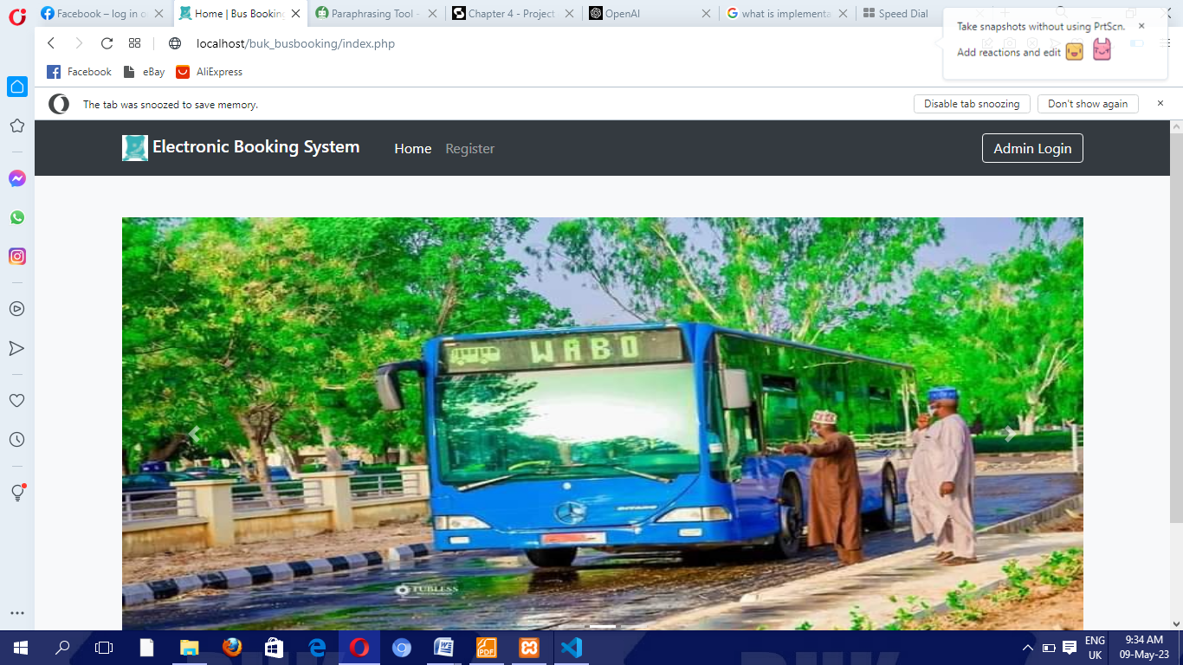

Figure 4.1: Home Page.

Each student is expected to interact with the registration form first, which will link him to his login page. Below is the registration form.

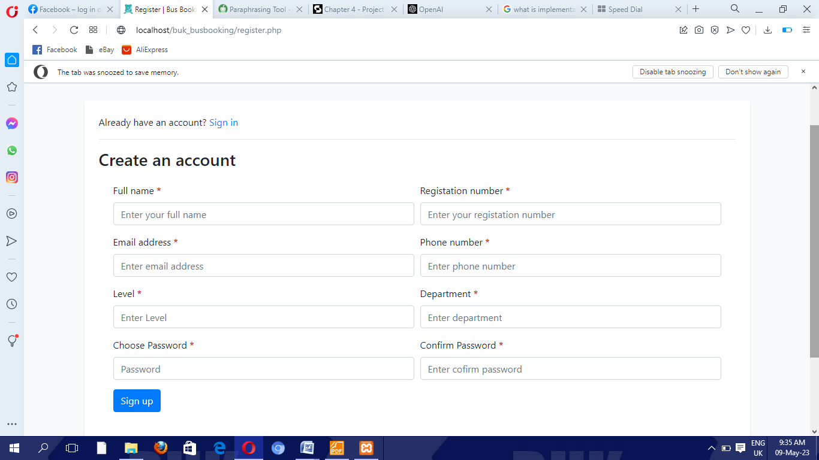

Figure 4.2: Student Registration Form.

After successfully registering the student will have to log in to his dashboard to access the booking services. Figure 4.3 show the login interface.

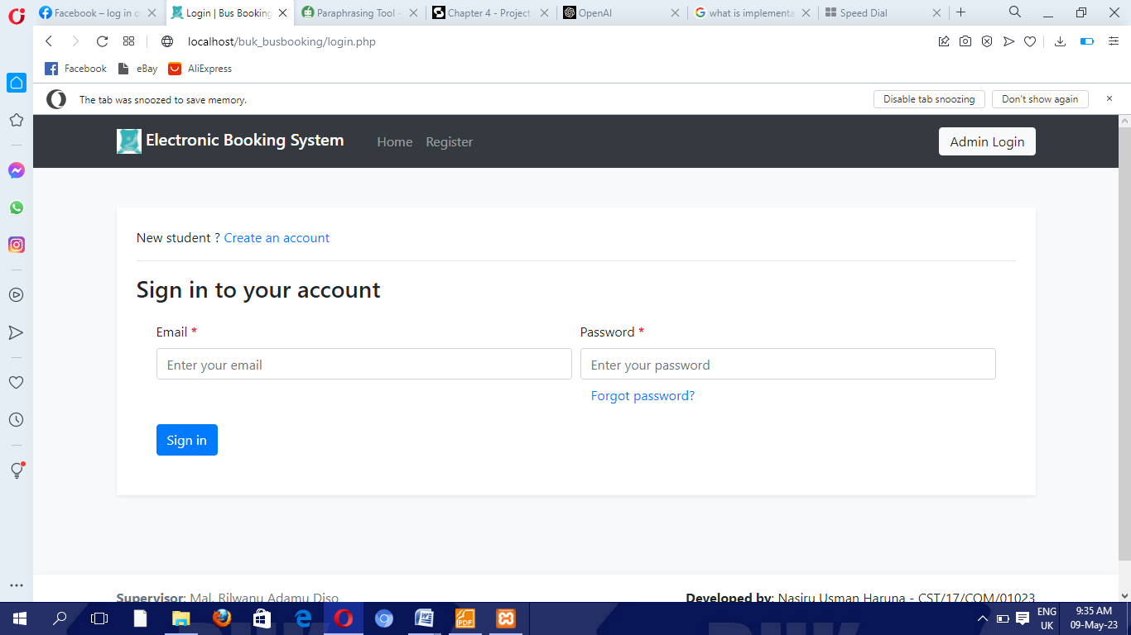

Figure 4.3: The login page.

After successfully login into the dashboard, they will have access to numerous services of the platform such as their profile, contact us, Reserve seat, booking history, and wallet.

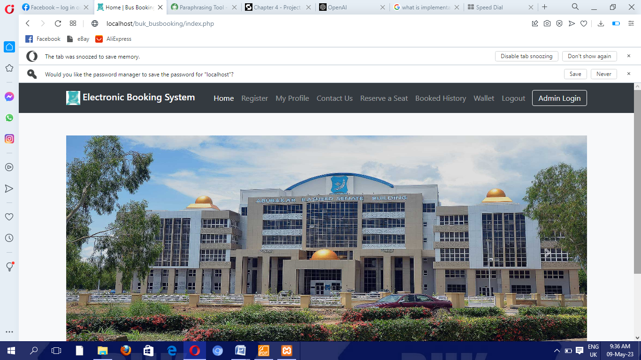

Figure 4.4 Dashboards.

Suppose a student wants to update his information or change his password, The My Profile page will allow him update to his information. Below is the My Profile page.

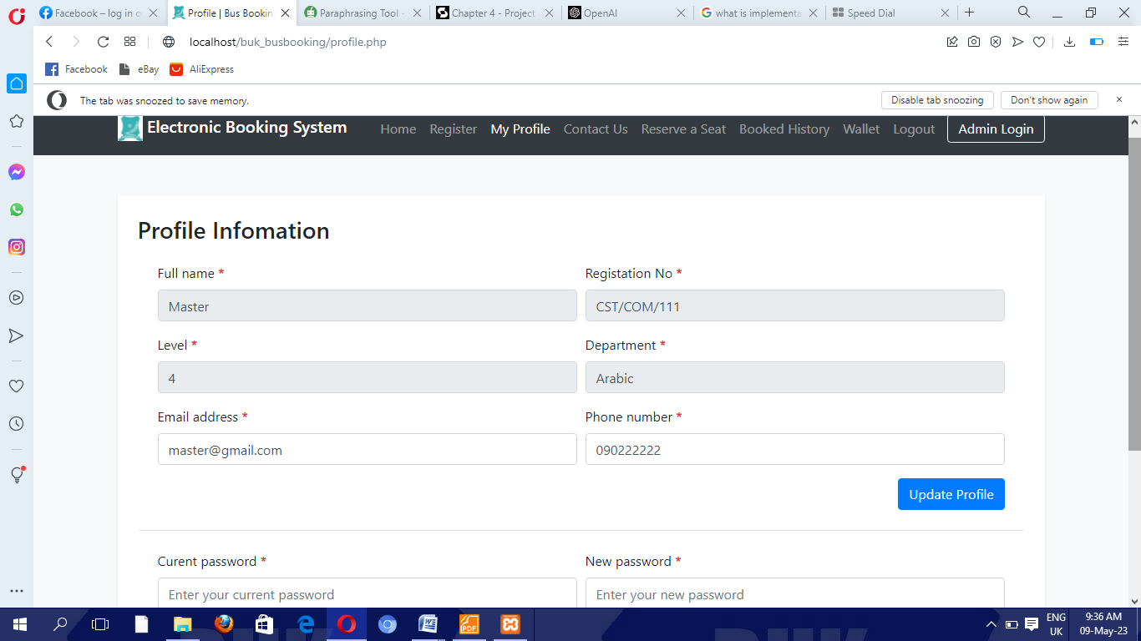

Figure 4.5: My Profile.

Another functionality of our software is to submit a report to the management of the buses through the below contact us page (figure 4.6).

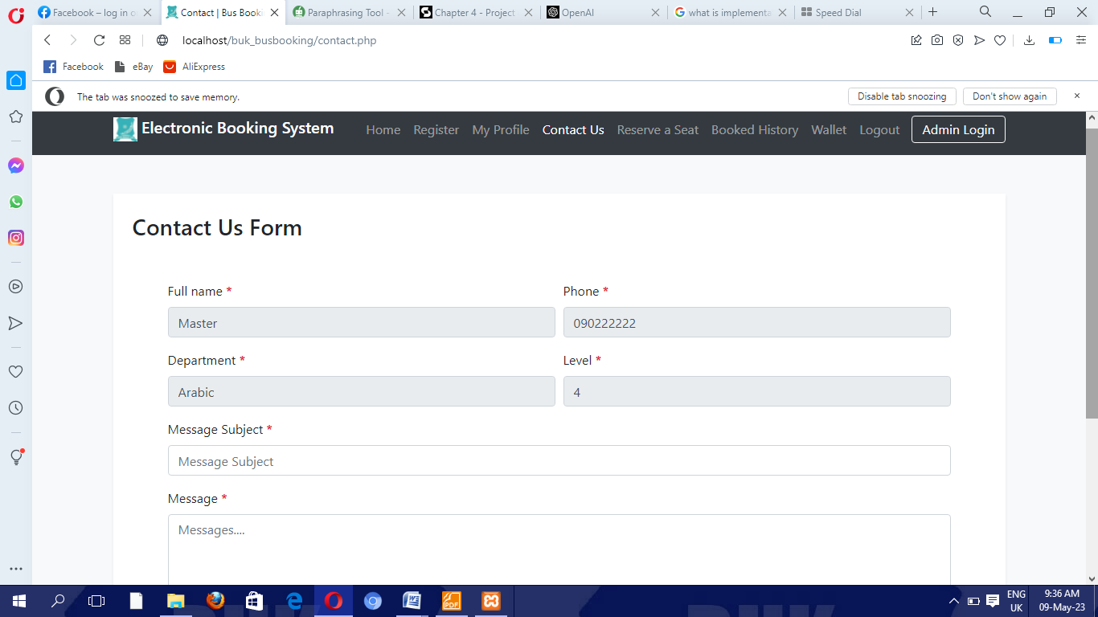

Figure 4.6: The Contact Page.

Reservation of seats is one of the main functionality of the system where users are able to book their seats by seeing the available buses at the pickup point. Below is the interface for the booking.

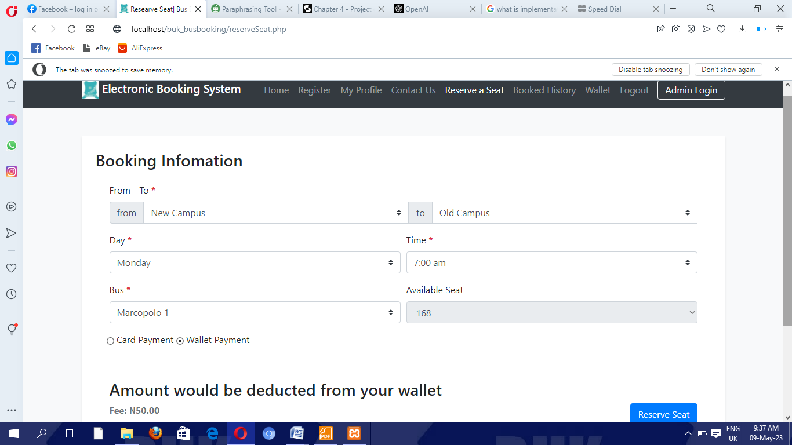

Figure 4.7: The Reserve Seat Page.

To enable the user to manage his information on his bookings, a history page was also built as portrayed in Figure 4.8.

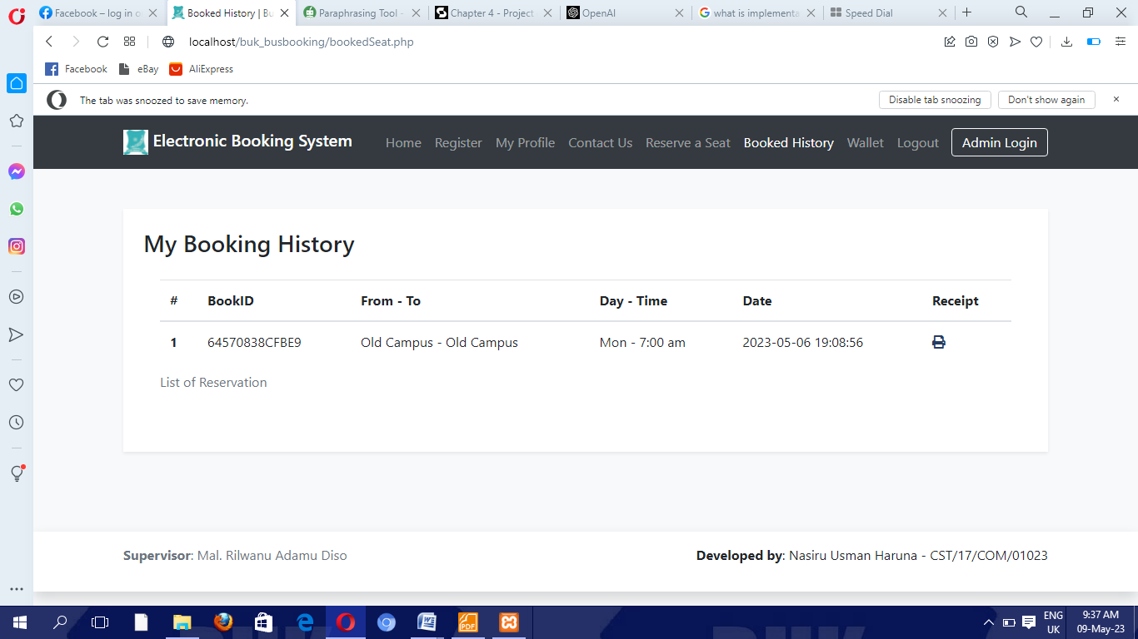

Figure 4.8 Booked Histories.

In order to mitigate financial constraints, a wallet was also built-into the system to allow users to top up the amount that’s sufficient to purchase their ticket. See figure 4.9

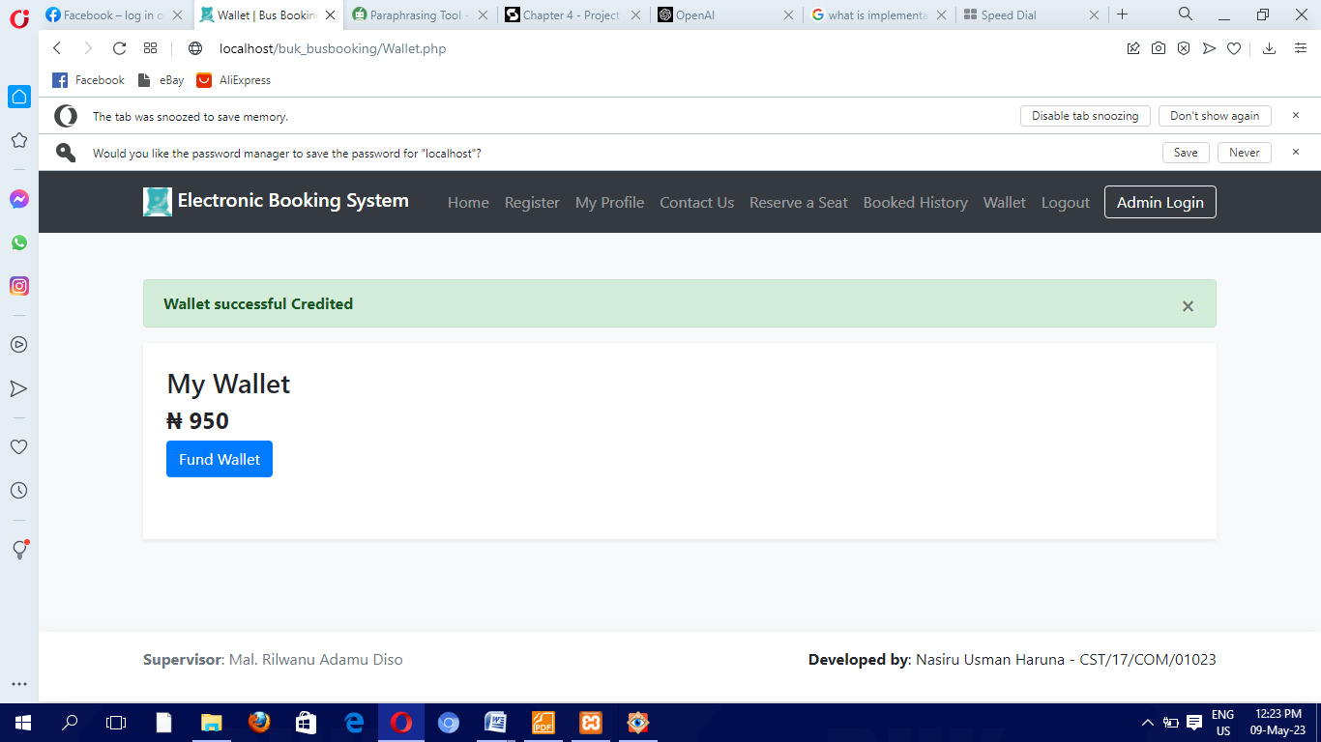

Figure 4.9 Wallets.

From the admin end, the admin login page was created to allow the admin access to manage the ticket booking. See Figure 4.10.

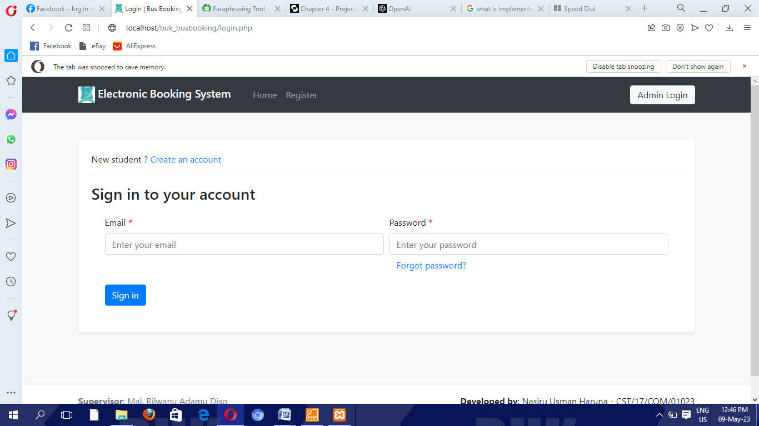

Figure 4.10: The admin login

Admin dashboard was created with a number of functionalities that allows him to respond to complaints received from the users, manage their record and add/delete users, update buses, and make changes to his profile. See Figure 4.11.

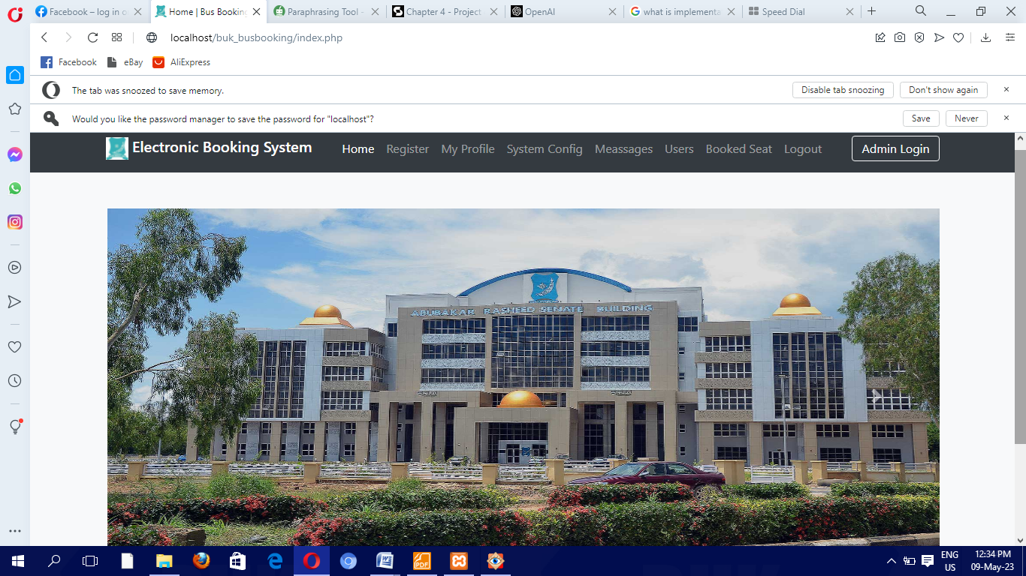

Figure 4.11 Admin Dashboard.

The admin My Profile page allows the admin to make changes/Update his information including password, username, etc. see Figure 4.12.

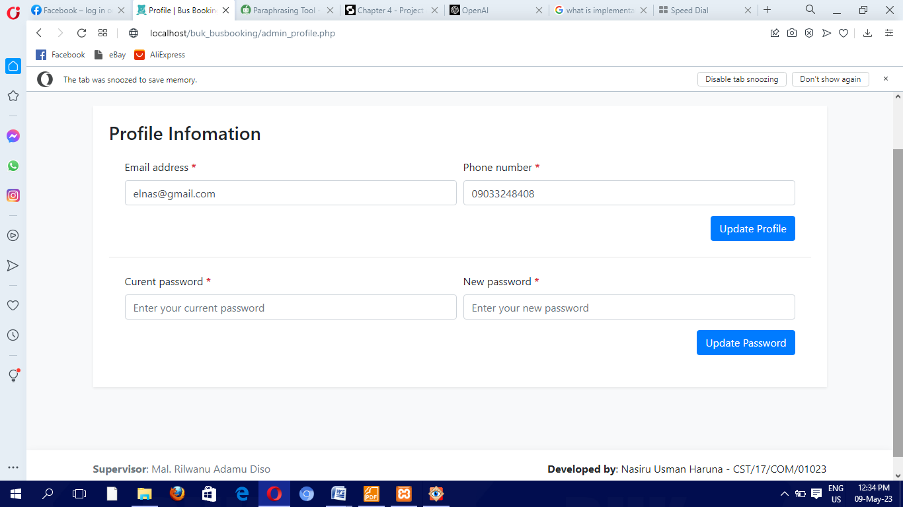

Figure 4.12. The admin Profile.

A system configuration page was created to enable the admin to add the buses available, update their terminal, number of seats available to allow users to book their seats. See figure 4.13

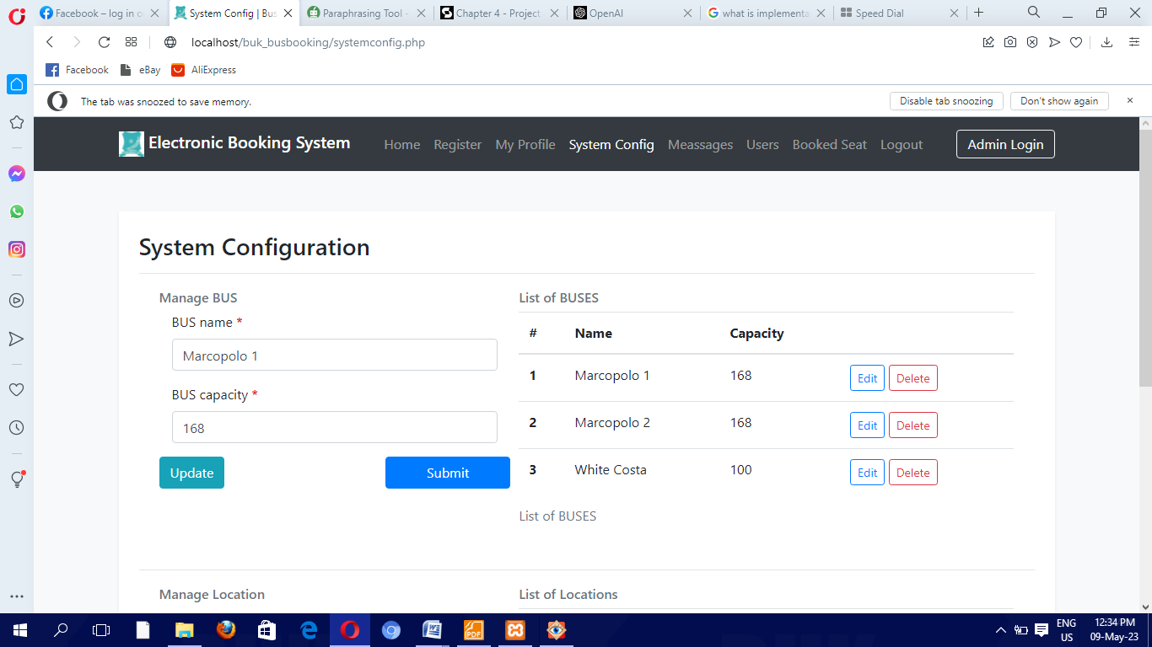

Figure 4.13: The System Configuration.

To respond to users’ complaints, a message page was created where the users can interact with the admin to report failed transactions, etc. see Figure 4.14.

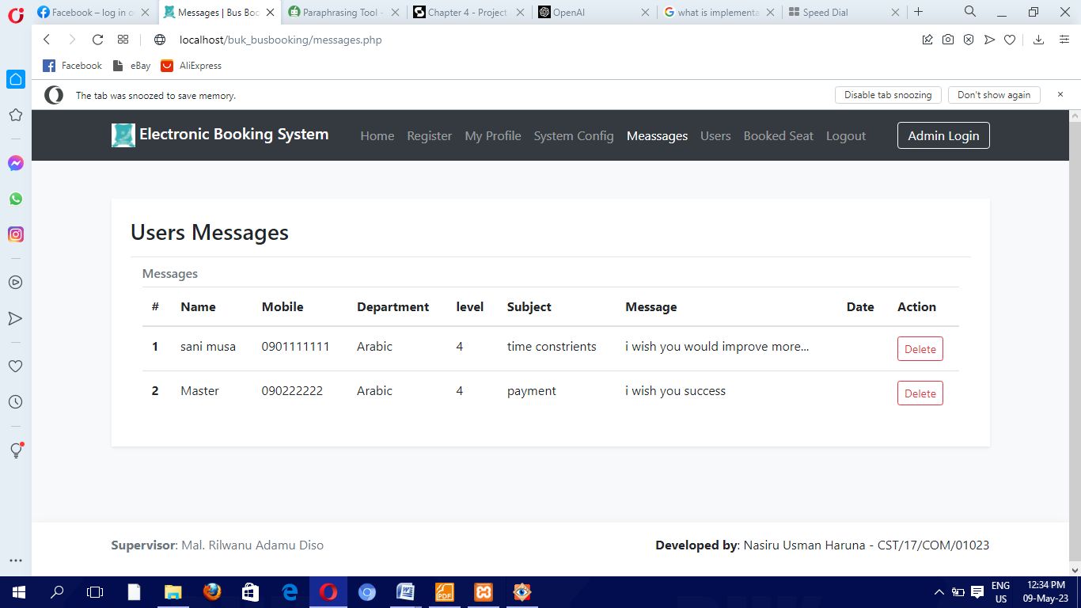  
Figure 4.14. The Messages

The users’ page was designed to keep a record of our users, improve our business and keep the record to the school for security purposes. See Figure 4.15.

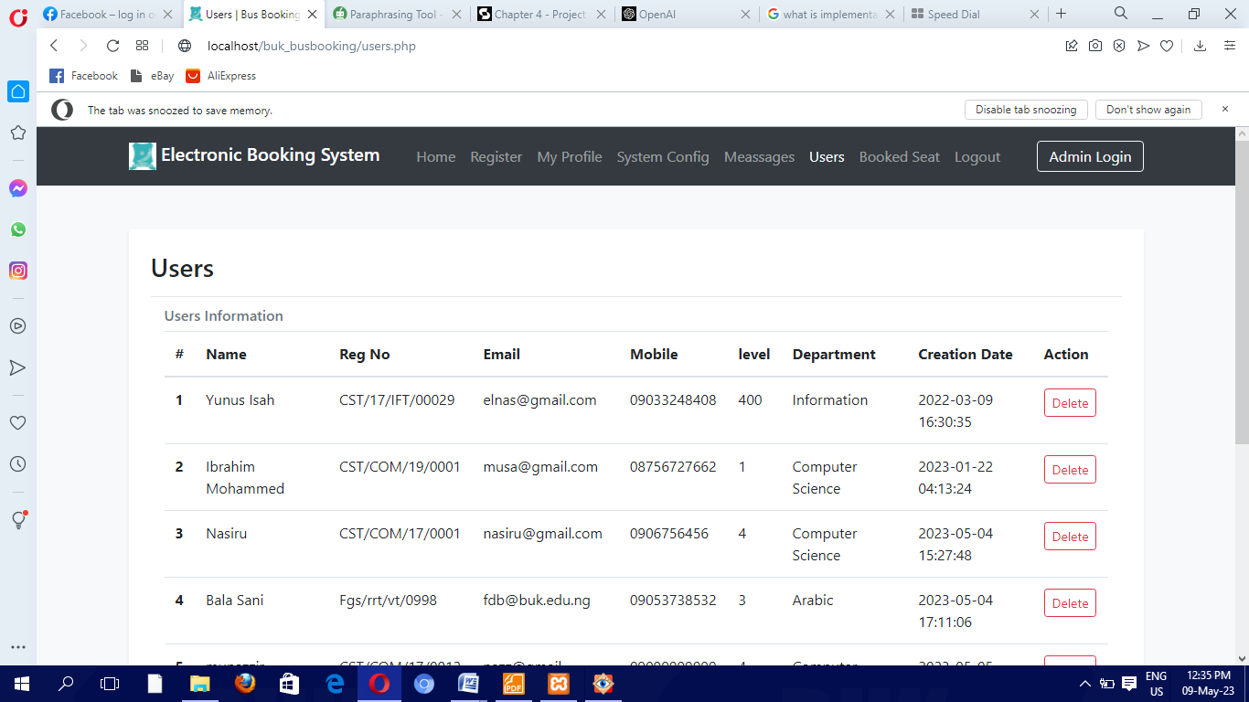

Figure 4.15: Users Page

To keep track of our ticketing, booked seat page was created to amount to the number of seats booked at a specific time/period. See Figure 4.16.

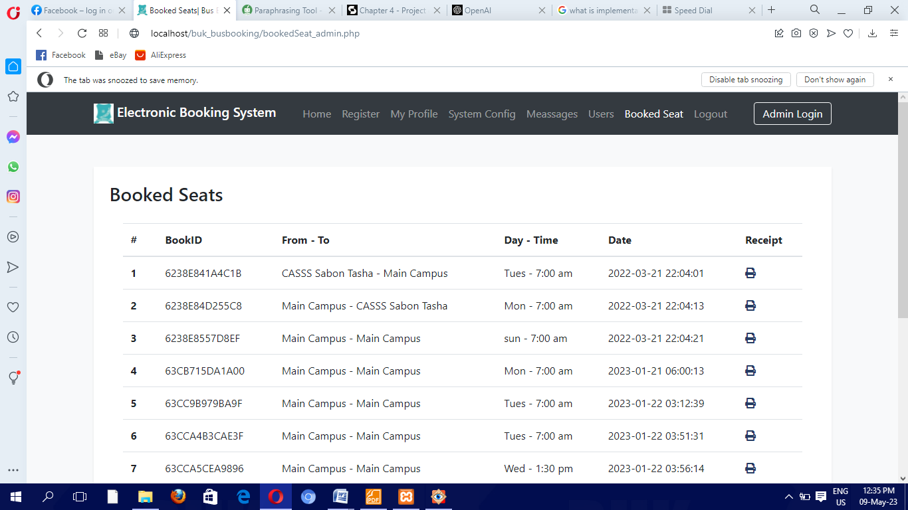

Figure 4.16: The Booked Seat page.

# 4.3Testing

The purpose of testing is to demonstrate that software performs as expected and to find any bugs before it is put to use. Testing can show whether errors exist, NOT whether they don't. Even though it is a costly activity in and of itself, releasing software without testing could result in costs that are significantly higher.

# 4.3.1Unit Testing

To make sure a program is operating properly, individual program units and their capabilities are tested as part of the unit testing process. The system was also tested to ensure proper and accurate execution.

**Table 4.1 Student Authentication test case table**

|  |  |  |  |  |  |  |  |
| --- | --- | --- | --- | --- | --- | --- | --- |
| **TEST**  **CASE**  **ID** | **TEST CASE**  **DESCRIPTION** | **PRECONDITION** | **TEST INPUT** | **STEPS** | **EXPECTED**  **RESULT** | **ACTUAL**  **RESULT** | **STATUS** |
| **TC-01** | Verify the  Fields in the authentication screen(email and password) | Student authentication screen must exist | All field  are blank  and  sign in  button is  clicked. | Click  Sign in  button | Warning  message  “Please  fill out  email and password field”. | The warning  message to  appear when  required  fields are  blank. | Pass |
| **TC-02** | Verify the  fields in the  authentication screen(email and password) | Student  authentication  screen must  exist | All field  are filled  wrongly  and  sign in  button is  clicked | Click  Sign in  button | Warning  message  “incorrect email or password” | The warning  message to  appear when  required field  is entered  wrongly | Pass |
| **TC-03** | Verify the  fields in the  authentication screen(email and password) | Student  authentication  screen must  exist | The all  fields are  entered  correctly | Click  Sign in  button | User is  authenticated into  the system | Student will  be  authenticated  Into the system | Pass |

**Table 4.2 Student Reserve seat test case table**

|  |  |  |  |  |  |  |  |
| --- | --- | --- | --- | --- | --- | --- | --- |
| **TEST CASE**  **ID** | **TEST CASE**  **DESCRIP**  **TION** | **PRECONDI**  **TION** | **TEST**  **INPUT** | **STEPS** | **EXPECTED**  **RESULT** | **ACTUAL**  **RESULT** | **STATU**  **S** |
| **TC-01** | Verify the  fields in the  reserve seat screen | Student must  be logged into  the system | All fields  are blank  and  reserve seat button is  clicked | Click  Reserve seat  button | Warning  message  “**No Seat Available check time or bus**” | **The warning**  **Message to**  **appear**  **when all**  **required**  **fields are**  **blank.** | Pass |
| **TC-02** | Verify the  fields in the  reserve seat | Reserve seat  screen must  exist | Some fields are filled and some fields are  Blank | Click  Reserve seat  button | Warning  message  “card fields are empty” | The  warning  message to  appear  when some  required  field is left  blank | Pass |
| **TC-03** | Verify the  fields in the  reserve seat  screen | Reserve seat  screen must  exist | The all  fields are  filled and checked | Click  submit  button | User  Reserve seat  is  submitted  into the  system for  booking | Student  Reserve seat  will be  submitted into  the system  and a  success  alert will be  displayed. | **Pass** |

**Table 4.3Adminlogin test case table**

|  |  |  |  |  |  |  |  |
| --- | --- | --- | --- | --- | --- | --- | --- |
| **TEST CASE ID** | **TEST CASE**  **DESCRIP**  **TION** | **PRECONDI**  **TION** | **TEST**  **INPUT** | **STEPS** | **EXPECTED**  **RESULT** | **ACTUAL RESULT** | **STATUS** |
| **TC-01** | Verify the  Fields in the admin login screen(email and password) | Admin login screen must exist. | All field  are blank  and  sign in  button is  clicked. | Click  Sign in  button | Warning  message  “Please  fill out  email and password field”. | The warning  message to  appear when  required  fields are  blank. | Pass |
| **TC-02** | Verify the  fields in the  admin login screen(email and password) | Admin  login  screen must  exist | All field  are filled  wrongly  and  sign in  button is  clicked | Click  Sign in  button | Warning  message  “incorrect email or password” | The warning  message to  appear when  required field  is entered  wrongly | Pass |
| **TC-03** | Verify the  fields in the  admin login screen(email and password) | Admin  Login  screen must  exist | The all  fields are  entered  correctly | Click  Sign in  button | Admin is  logged into  the system | Admin will  be  logged in  Into the system | Pass |

**Table 4.2 Student Contact us test case table**

|  |  |  |  |  |  |  |  |
| --- | --- | --- | --- | --- | --- | --- | --- |
| **TEST CASE ID** | **TEST CASE**  **DESCRIP**  **TION** | **PRECONDI**  **TION** | **TEST**  **INPUT** | **STEPS** | **EXPECTED**  **RESULT** | **ACTUAL RESULT** | **STATUS** |
| **TC-01** | To verify fields in the contact us screen | The user must be logged into the system | All fields are left blank | Click on the send button | The warning message “Please fill out all the fields” will be displayed | The warning message appears when the required fields are blank | Pass |
| **TC-02** | To verify fields in the contact us screen | The user must be logged into the system | Some of the fields are left blank | Click on the send button | The message “Please fill out all the fields” will be displayed | The warning message appears when some required fields are blank | Pass |
| **TC-03** | To verify fields in the contact us screen | The user must be logged into the system | All the required fields are filled | Click on the send button | message “well-done feedback sent successfully” will be displayed | The success message to appear when the required fields are filled and sent | Pass |

# 4.3.2 System Testing:

Testing interfaces between integrated elements is a technique known as system testing. The system was tested throughout the building period and the scope was perfectly validated.

# CHAPTER FIVE

# SUMMARY AND CONCLUSION

# 5.1 Introduction

This chapter contains a summary, conclusion, and recommendation of this project.

# 5.2 Summary

The Electronic ticket booking system was designed and implemented for the students of Bayero University Kano and the Deanery of student affairs to carry out the online ticketing purchase and have full interaction with the students of the university more efficiently and reliably. The student will be able to use the new system to reserve a seat online, pay for it, and check the availability of a seat, while the deanery of student affairs and the counter attendant will be able to view the reserved ticket, answer inquiries, and maintain the records of students.

Utilizing the proper modeling tools, the system's study and design were completed and incorporated into a single system. The students must register before having access to the platform. The student is enabled to top-up his wallet to allow him an online payment or payment with a credit card after he checks the availability and chooses his terminal and time of travel. The ticket cannot be lost or forgotten because of the ability of the system to save the booking history. For inquiries, students were provided with a contact page to allow them to send a suggestion, complaints, or reports.

The first chapter focused on the overall context of the study, the problem statement, the project's goals, which included automating the manual way of ticket purchasing for Bayero University Kano students, as well as the project's scope and limitations.

The second chapter (literature review) describes an understandable and conversant review of some relevant works completed in the online ticketing system and related system reviews. In this part, six chosen works of literature were reviewed to learn about the work and effort that had been combined to achieve a good and quality result.

The waterfall model of the SDLC, requirement elicitation, and system analysis and design were thoroughly justified in chapter three (system analysis and design). Requirements for the proposed system were gathered through the evaluation of related works, interviews, and observation. Both the proposed automated system and the current manual system were discussed. Use case diagrams were utilized for the analysis and system design phases, while class and activity diagrams were used for assessing the functional and non-functional needs of the current system.

System implementations, system testing, and system maintenance are covered in the four chapters (System implementation, testing, and maintenance). This transforms the chapter three design into an executable system. In this chapter, screenshots of system features were presented. Unit testing, integration testing, and system testing are the three (3) testing phases that are used to define how the system functions.

# 5.3 Conclusion

The case study is Bayero university kano, with approximately 37,214 undergraduate students from 83 academic departments within the seventeenth faculties in the institute. But we are targeting students that make use of school buses, specifically Students Affairs buses (moving from the new campus to the old campus). These buses were controlled and managed by the student affairs of the university.

ICT devices are now so deeply ingrained in daily life that successful management is impossible without their availability. A lot of students have undergone suffering, a huge amount of these tickets have been reported lost among the students and the counter attendant, and no emergency record if any problem occurs.

Through the use of the automated system, the admin can have access to the record of these students, track the number of booked tickets, and also have a history of inquiries from the students. Also this help to:

1. Since the system will be web-based, allow for better storage.
2. A more efficient, effective, payment system.
3. Assist in improving their marketing and reducing the cost of the tickets.
4. student information has been improved.
5. Prevent data loss due to natural disasters.

Future researchers could learn from the study about the advantages, downsides, and impact of building web solutions for improving electronic ticketing and apply that knowledge to their future research. By improving the platform in a way the admin and the counter attendant can have a real-time location of their buses using advanced developmental tools and application programming interfaces. It was determined that the online student ticketing system was a success. The system's objective is to automate the student ticket booking process in order to increase its flexibility. The web-based system can do the tasks required of it in a flexible, cost-effective, and efficient manner.

# 5.4 Recommendation

For further enhancement of the electronic booking system, the following are some recommendations.

1. With the emergence of new technologies, the system needs to be updated to improve its functionality and stop it from outdated.
2. The system should have live chat features, to enable effective communication.

# REFERENCES

Adam, T. (2019). *Automated Bus Ticket Reservation System for Ethiopian Bus Transport System*. *21*(3), 22–27. https://doi.org/10.9790/0661-2103022227

Alaya, S. M. (2014). *Development of an Online Bus Ticket Reservation System for a Transportation Service in Nigeria*. *5*(12), 9–18.

Callista, A., Sari, J. R., & Si, S. (2011). *Developing A Bus Ticket Reservation Web Application At PT . Setia Jiwana Sakti*. *2011*(Ies), 978–979.

Campos Ferreira, M., Galvão Dias, T., & Falcão e Cunha, J. (2020). *An In-Depth Study of Mobile Ticketing Services in Urban Passenger Transport*. *January*, 145–165. https://doi.org/10.4018/978-1-7998-2112-0.ch008

Journal, I., Development, S., & Policy, W. (2004). SYSTEM IN NIGERIA THROUGH THE APPLICATION OF IT-BASED Aims of the Research Boundaries of the Research. *International Journal of Sustainable Development & World Policy*, *1*(1), 1–28.

Nwakanma, I. C., Etus, C., Ajere, I., & Agomuo, U. (2015). Key words : OBTRS , Electronic Ticketing , ITC , Reservation , Transportation Background of Study The prevalent view in various global circles is that man is presently living in an. *International Journal of Computer Science and Statistics*, *1*(July 2018), 1–17.

Soegotto, D. S., & Prasetyo, T. (2019). Application of Online Ticket as a Method in Purchasing Bus Tickets. *IOP Conference Series: Materials Science and Engineering*, *662*(2). https://doi.org/10.1088/1757-899X/662/2/022118